**GENERAL HUMAN BIOLOGY – YEAR 12**

**TASK 9 – INFECTIOUS DISEASE TEST**

**NAME: _______________________________________ WEIGHTING: 10%**

**TEST DATE: _______________________________________ MARK: ____ / 43**

***MULTIPLE CHOICE (13 MARKS)***

Circle the correct answer

1. An infectious disease is one that is ___________.
   1. Spread from person to person
   2. Caused by all bacteria
   3. Transferred by mosquitos
   4. Caused by a pathogen or its products
2. Which of the following is an example of the spreading of disease by direct contact?
   1. Sneezing
   2. Coughing
   3. Kissing
   4. Sweating
3. Which of the following is a transmissible (passed from host to host) disease?
   1. Scurvy
   2. Food poisoning
   3. Diabetes
   4. Cancer
4. Pathogens are __________.
   1. Disease causing microbes or germs
   2. Non disease causing and are beneficial
   3. A natural part of the body
   4. Always treated with antibiotics
5. The body has several defences to protect itself from disease including __________.
   1. The skin
   2. Mucus produced from the lungs
   3. Stomach acid
   4. All of the above
6. Which of the following cells release histamine in response to an allergen, foreign material or pathogen?
   1. Phagocytes
   2. Red blood cells
   3. Mast cells
   4. B cells
7. What type of immune cell engulfs invading pathogens?
   1. Phagocyte
   2. Osteocyte
   3. Chondrocyte
   4. Antigen
8. Whilst enjoying the sunshine, Jaxon gets stung by a bee. What would be four (4) indicators that her body is going through the Inflammatory Response?
   1. Heat, swelling, hives, runny nose
   2. Redness, pain, swelling, heat
   3. Pain, hives, redness, burning sensation
   4. Burning sensation, hives, pain, heat
9. Sam is preparing wooden beams when he receives a nasty splinter. Her immune system would start by causing what to occur at the sight of injury?
   1. Mast cells release histamine
   2. The capillaries become leaky to grant phagocytes access to the invading pathogen
   3. Nothing happens at the start because the body does not recognise the invading pathogens
   4. Clotting in the injury area occurs
10. Which of the following diseases is an/are examples of cross-species transmission?
    1. HIV: from monkeys to chimpanzees to humans
    2. Swine flu: from poultry to pigs to humans
    3. SARS: from bats immediately to humans
    4. Options a and b only
11. A HIV+ mother is feeding her child; the child is then infected with the HIV virus. What type of transmission does this demonstrate?
    1. Horizontal transmission
    2. Cross-species transmission
    3. Mother-child transmission
    4. Vertical transmission
12. Which of the following is **NOT** a method of preventing transmission?
    1. Quarantine
    2. Vaccinations
    3. Vitamins
    4. Face mask
13. Identify an example of specific body defence mechanism
    1. Acidic environment
    2. Antibodies
    3. Antigens
    4. Ear wax

***SHORT ANSWER SECTION (19 MARKS)***

1. What is the generalised system name that helps prevent you from getting a disease? (1 mark)

1. What signs of inflammation can you see in these images? (3 marks)

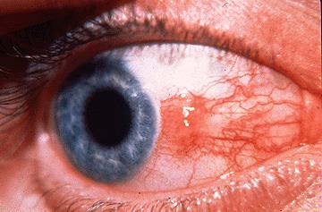 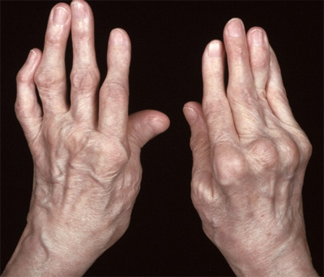 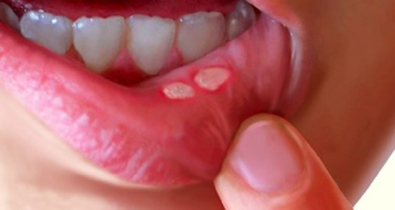   
  
**__________________________** **__________________________**  **__________________________**

1. To be infected by a pathogen, there are a number of linked stages, called the Chain of Infection, that must be satisfied (occur). State and describe each stage involved in the Chain of Infection.

(6 marks)

|  |
| --- |
|  |
|  |
|  |
|  |
|  |
|  |
|  |
|  |

1. Fill-in the table below, comparing the features of bacteria and viruses (3 marks)

|  |  |  |
| --- | --- | --- |
|  | **How more copies are made inside a host** | **How pathogen is treated** |
| **BACTERIA** |  |  |
| **VIRUS** |  |  |

1. Draw a line to match the pathogens with their example (4 marks)

|  |  |  |
| --- | --- | --- |
| Bacteria |  | Tinea/Athlete’s Foot |
| Virus |  | Malaria |
| Parasite |  | Bird flu |
| Fungi |  | E. Coli |

1. Parasites rarely kill their host. Suggest a possible reason. (2 marks)

|  |
| --- |
|  |
|  |
|  |
|  |
|  |
|  |
|  |

***EXTENDED GRAPHING PROBLEM (11 MARKS)***

1. A medical researcher deliberately infected himself with bacteria known to cause a specific disease. His blood was analysed before the infection and then every day afterwards, and the number of bacteria was analysed. Any display of symptoms of the disease was also noted. The results are shown in table 1. An asterisk (*) means that there were symptoms of the disease present on that day.

|  |  |  |  |  |  |  |  |  |  |  |
| --- | --- | --- | --- | --- | --- | --- | --- | --- | --- | --- |
| **Time (days)** | **0** | **1** | **2** | **3** | **4** | **5** | **6** | **7** | **8** | **9** |
| **No. of bacteria** | 0 | 100 | 200 | 400 | 600 | 900 | 2600 | 5900 | 7800 | 7900 |

|  |  |  |  |  |  |  |  |  |  |  |
| --- | --- | --- | --- | --- | --- | --- | --- | --- | --- | --- |
| **Time (days)** | **10** | **11** | **12** | **13** | **14** | **15** | **16** | **17** | **18** | **19** |
| **No. of bacteria** | 6100 | 3900 | 2200 | 1200 | 700 | 600 | 400 | 200 | 100 | 50 |

*Table 1*

1. Draw a line graph of the above data. (5 marks)
2. What is meant by the term symptom? (1 mark)

|  |
| --- |
|  |
|  |
|  |

1. On the graph, show when the symptoms were apparent. (1 mark)

The incubation period is the time taken from infection to the first symptoms of the diseased.

1. Show the incubation period on the graph. (1 mark)
2. What is the smallest number of bacteria that caused symptoms in the subject? Explain your answer. (3 marks)

|  |
| --- |
|  |
|  |
|  |
|  |
|  |
|  |
|  |

***END OF TEST***